. JAVA ASSIGNMENT-01

Create a program that allows users to customize a car build and prints all the selected options. The user will provide input via standard input, and the output will be displayed on standard output.

**Car Manufacturer:**

* Mahindra
* Tata
* Maruti

**Model (for Mahindra):**

* Scorpio
* Thar
* Scorpio N
* XUV 700

**Transmission Variant:**

* Manual
* Automatic

**Fuel Type:**

* Diesel
* Petrol
* CNG

**Accessories:**

**Color**

* Silver
* Blue
* Yellow

**Location:**

* Delhi
* Bangalore
* Hyderabad

Chennai   
  
import java.util.Scanner;  
  
public class Main {  
  
 public static void main(String[] args) {  
 Scanner scanner = new Scanner(System.*in*);  
  
 System.*out*.println("Choose Car Brand:");  
 System.*out*.println("1. Mahindra");  
 System.*out*.println("2. Tata");  
 System.*out*.println("3. Maruti");  
 int brandChoice = scanner.nextInt();  
 scanner.nextLine();  
  
 String brand = "";  
 switch (brandChoice) {  
 case 1 -> brand = "Mahindra";  
 case 2 -> brand = "Tata";  
 case 3 -> brand = "Maruti";  
 default -> {  
 System.*out*.println("Invalid selection.");  
 return;  
 }  
 }  
  
 String model = "";  
 if (brand.equals("Mahindra")) {  
 System.*out*.println("Select Mahindra Model:");  
 System.*out*.println("1. Scorpio");  
 System.*out*.println("2. Thar");  
 System.*out*.println("3. Scorpio N");  
 System.*out*.println("4. XUV 700");  
 int modelChoice = scanner.nextInt();  
 scanner.nextLine();  
  
 switch (modelChoice) {  
 case 1 -> model = "Scorpio";  
 case 2 -> model = "Thar";  
 case 3 -> model = "Scorpio N";  
 case 4 -> model = "XUV 700";  
 default -> {  
 System.*out*.println("Invalid model option.");  
 return;  
 }  
 }  
 }  
  
 System.*out*.println("Choose Gearbox Type:");  
 System.*out*.println("1. Manual");  
 System.*out*.println("2. Automatic");  
 int transmissionInput = scanner.nextInt();  
 scanner.nextLine();  
  
 String transmission = "";  
 switch (transmissionInput) {  
 case 1 -> transmission = "Manual";  
 case 2 -> transmission = "Automatic";  
 default -> {  
 System.*out*.println("Invalid gearbox option.");  
 return;  
 }  
 }  
  
 System.*out*.println("Choose Fuel Option:");  
 System.*out*.println("1. Diesel");  
 System.*out*.println("2. Petrol");  
 System.*out*.println("3. CNG");  
 int fuelOption = scanner.nextInt();  
 scanner.nextLine();  
  
 String fuel = "";  
 switch (fuelOption) {  
 case 1 -> fuel = "Diesel";  
 case 2 -> fuel = "Petrol";  
 case 3 -> fuel = "CNG";  
 default -> {  
 System.*out*.println("Invalid fuel type.");  
 return;  
 }  
 }  
  
 System.*out*.println("Pick a Color:");  
 System.*out*.println("1. Silver");  
 System.*out*.println("2. Blue");  
 System.*out*.println("3. Yellow");  
 int colorInput = scanner.nextInt();  
 scanner.nextLine();  
  
 String color = "";  
 switch (colorInput) {  
 case 1 -> color = "Silver";  
 case 2 -> color = "Blue";  
 case 3 -> color = "Yellow";  
 default -> {  
 System.*out*.println("Invalid color.");  
 return;  
 }  
 }  
  
 System.*out*.println("Choose City for Delivery:");  
 System.*out*.println("1. Delhi");  
 System.*out*.println("2. Bangalore");  
 System.*out*.println("3. Hyderabad");  
 System.*out*.println("4. Chennai");  
 int cityInput = scanner.nextInt();  
 scanner.nextLine();  
  
 String location = "";  
 switch (cityInput) {  
 case 1 -> location = "Delhi";  
 case 2 -> location = "Bangalore";  
 case 3 -> location = "Hyderabad";  
 case 4 -> location = "Chennai";  
 default -> {  
 System.*out*.println("Invalid city.");  
 return;  
 }  
 }  
  
 System.*out*.println("\n--- Customized Car Summary ---");  
 System.*out*.println("Brand: " + brand);  
 if (!model.isEmpty()) {  
 System.*out*.println("Model: " + model);  
 }  
 System.*out*.println("Transmission: " + transmission);  
 System.*out*.println("Fuel: " + fuel);  
 System.*out*.println("Color: " + color);  
 System.*out*.println("Delivery City: " + location);  
 }  
}



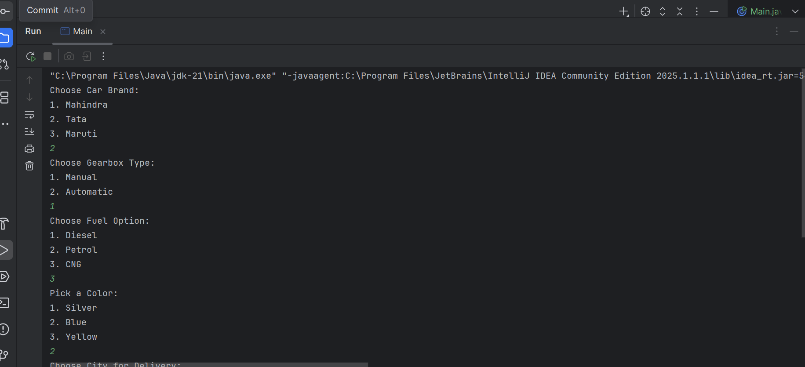  
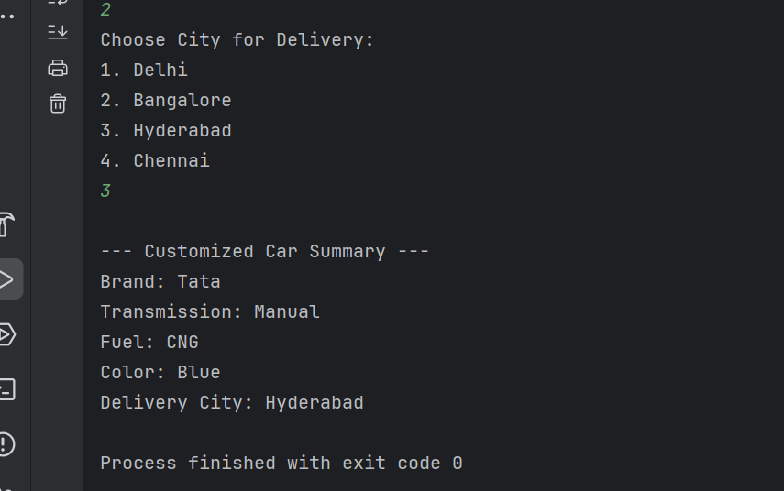  
  
  
Write a program to calculate the annual tax owed by an individual based on their salary, age, and other parameters. The user will input their details, and the program will output the total tax amount.

**Parameters:**

1. **Salary (in INR):**
2. Annual salary of the individual.
3. **Age (in years):**
4. Age of the individual.
5. **Investment in Tax-saving Instruments (in INR):**
6. Amount invested in tax-saving instruments like PPF, ELSS, etc.
7. **Health Insurance Premium (in INR):**
8. Annual health insurance premium paid by the individual.
9. **Home Loan Interest (in INR):**
10. Annual interest paid on a home loan.

**Tax Slabs:**

1. **For individuals below 60 years:**
2. Up to ₹2,50,000: No tax
3. ₹2,50,001 to ₹5,00,000: 5%
4. ₹5,00,001 to ₹10,00,000: 20%
5. Above ₹10,00,000: 30%
6. **For individuals between 60 and 80 years:**
7. Up to ₹3,00,000: No tax
8. ₹3,00,001 to ₹5,00,000: 5%
9. ₹5,00,001 to ₹10,00,000: 20%
10. Above ₹10,00,000: 30%
11. **For individuals above 80 years:**
12. Up to ₹5,00,000: No tax
13. ₹5,00,001 to ₹10,00,000: 20%
14. Above ₹10,00,000: 30%

**Deductions:**

1. **Section 80C:**
2. Maximum deduction of ₹1,50,000 for investments in tax-saving instruments.
3. **Section 80D:**
4. Maximum deduction of ₹25,000 for health insurance premium (₹50,000 for senior citizens).
5. **Section 24:**
6. Maximum deduction of ₹2,00,000 for home loan interest.

**Output:**

The program should output the total tax amount owed by the individual after considering the applicable deductions.

import java.util.Scanner;  
  
public class Main {  
  
 public static void main(String[] args) {  
 Scanner scanner = new Scanner(System.*in*);  
  
 System.*out*.print("Annual Income (INR): ");  
 double salary = scanner.nextDouble();  
  
 System.*out*.print("Age (years): ");  
 int age = scanner.nextInt();  
  
 System.*out*.print("Investment in 80C Instruments (INR): ");  
 double investment = scanner.nextDouble();  
  
 System.*out*.print("Health Insurance Premium (INR): ");  
 double healthInsurance = scanner.nextDouble();  
  
 System.*out*.print("Interest on Home Loan (INR): ");  
 double homeLoanInterest = scanner.nextDouble();  
  
 scanner.close();  
  
 double allowed80C = Math.*min*(investment, 150000);  
 double allowed80D = Math.*min*(healthInsurance, (age >= 60 ? 50000 : 25000));  
 double allowed24B = Math.*min*(homeLoanInterest, 200000);  
  
 double deductions = allowed80C + allowed80D + allowed24B;  
  
 double taxable = salary - deductions;  
 if (taxable < 0) {  
 taxable = 0;  
 }  
  
 double totalTax = *computeTax*(taxable, age);  
  
 System.*out*.println("\n--- Tax Computation Result ---");  
 System.*out*.println("Total Deducted Amount: ₹" + deductions);  
 System.*out*.println("Final Taxable Income: ₹" + taxable);  
 System.*out*.println("Tax Payable: ₹" + totalTax);  
 }  
  
 public static double computeTax(double income, int age) {  
 double result = 0;  
  
 if (age < 60) {  
 if (income <= 250000) {  
 result = 0;  
 } else if (income <= 500000) {  
 result = (income - 250000) * 0.05;  
 } else if (income <= 1000000) {  
 result = 12500 + (income - 500000) * 0.20;  
 } else {  
 result = 112500 + (income - 1000000) * 0.30;  
 }  
 } else if (age <= 80) {  
 if (income <= 300000) {  
 result = 0;  
 } else if (income <= 500000) {  
 result = (income - 300000) * 0.05;  
 } else if (income <= 1000000) {  
 result = 10000 + (income - 500000) * 0.20;  
 } else {  
 result = 110000 + (income - 1000000) * 0.30;  
 }  
 } else {  
 if (income <= 500000) {  
 result = 0;  
 } else if (income <= 1000000) {  
 result = (income - 500000) * 0.20;  
 } else {  
 result = 100000 + (income - 1000000) * 0.30;  
 }  
 }  
  
 return result;  
 }  
}

output:  
